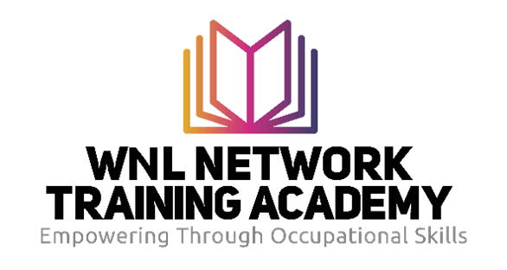

One Day Life Skills Workshop - Application Form:
- Personal Information:

- Full Name:

- Date of Birth:

- Gender:

- Contact Number:

- Email Address:
- Residential Address:

  - Street Address:

  - City/Town:

  - Postal Code:
- Educational Background:

- Highest Level of Education Completed:

- Name of School/Institution:

- Year of Graduation:
- Skills and Qualities:
- Please briefly describe why you are interested in attending the Life Skills Workshop and how you believe it will add value to your personal and professional life. (200 words maximum)

- Availability and Commitment:
Are you available to commit to the entire duration of the Life Skills Workshop (a full day)?
(Yes No )
- If no, please provide details of any potential conflicts:

- Documentation:
Please attach the following documents:
- Certified Copy of South African ID
- Certified Copy of your Highest Level of Education Completed
- Proof of residential address (e.g., utility bill, lease agreement or letter confirming the residential address etc).
- Declaration:
I hereby declare that the information provided in this application form is accurate and complete to the best of my knowledge. I understand that any misrepresentation may result in disqualification from the programme. I understand that this course is sponsored and if I do not complete the course and dropout, I will be liable for costs.
Signature: _____________________________ Date: _______________
- Data Protection (POPIA) Agreement:
By submitting this application, I consent to the collection and processing of my personal data by the WNL Network Training Academy for the purpose of assessing my eligibility for the life skills workshop. I understand that my data will be handled in accordance with the Protection of Personal Information Act (POPIA) and will be used solely for programme-related communication and selection purposes.
Signature: _____________________________ Date: _______________

Selection Process and Notification:
If you do not receive a response from the WNL Network Training Academy within two weeks of the application deadline, please consider your application unsuccessful. We kindly request your patience during the selection process, as we carefully review all applications.
The WNL Network Training Academy reserves the right to select or disqualify applicants based on the established criteria and programme requirements. Our decisions are made with the best interests of the programme and its objectives in mind.

Please return this completed form and supporting documents to tersiao@wnlacademy.com by the due date (10 October 2023).

